**INTEGRATION REPORTS (IT)**

1. **Integration of menu() in main().**

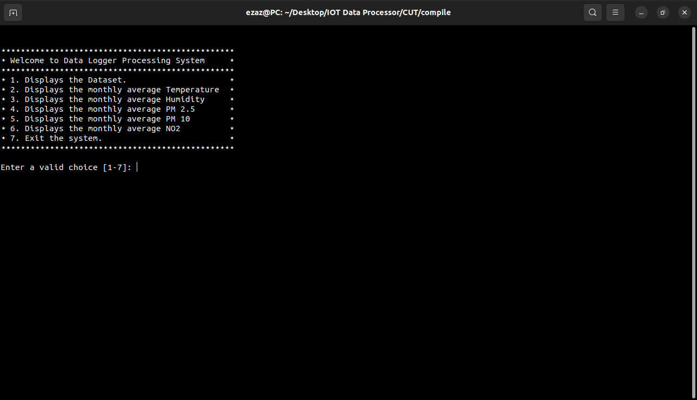

1. 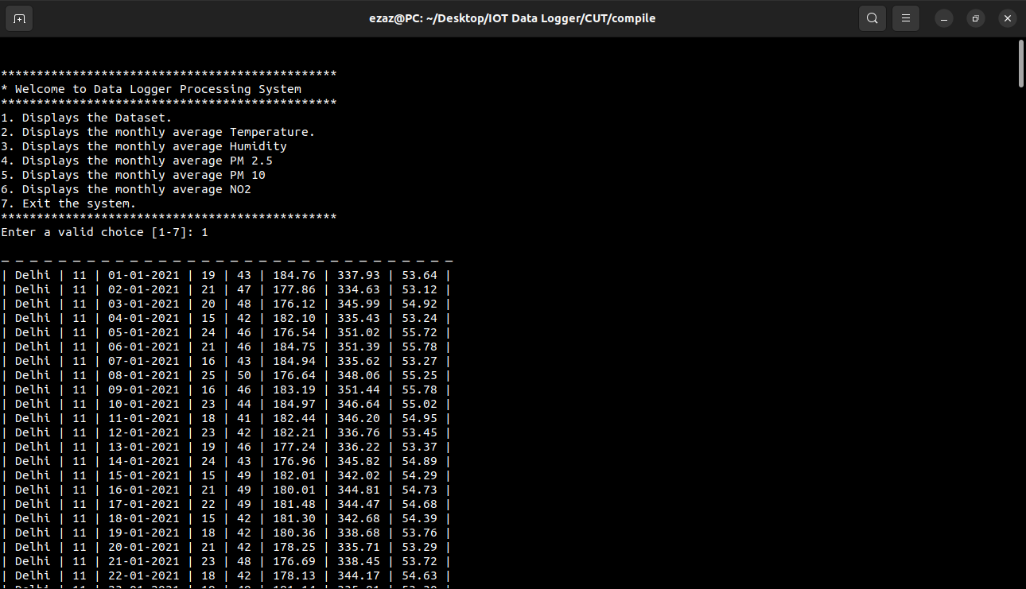**Integration of loadFromFile() in menu().**
2. **Integration of printLinkedList() in menu().**



1. **Integration of avgTemperature() in menu().**

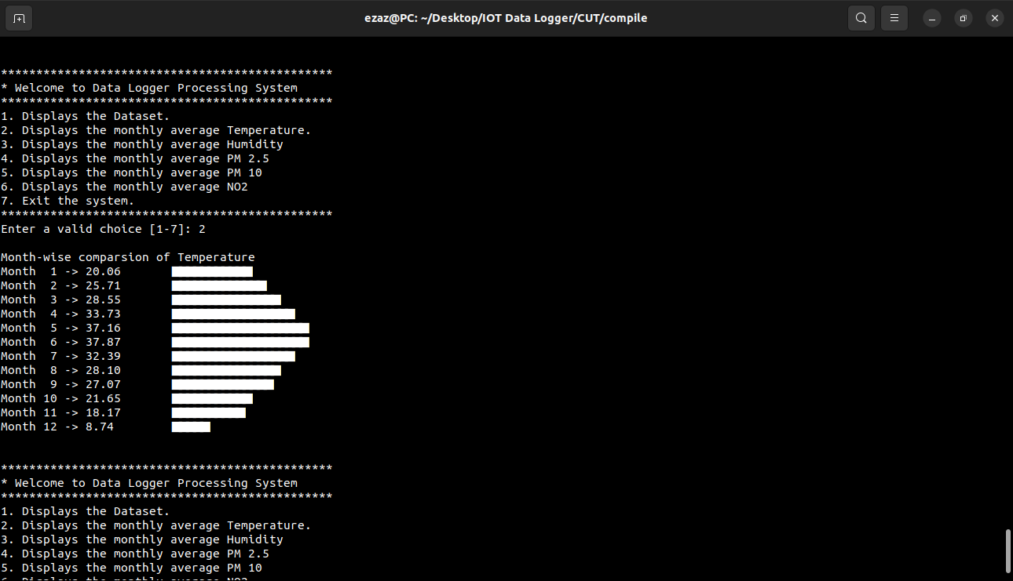

1. **Integration of avgHumidity () in menu().**

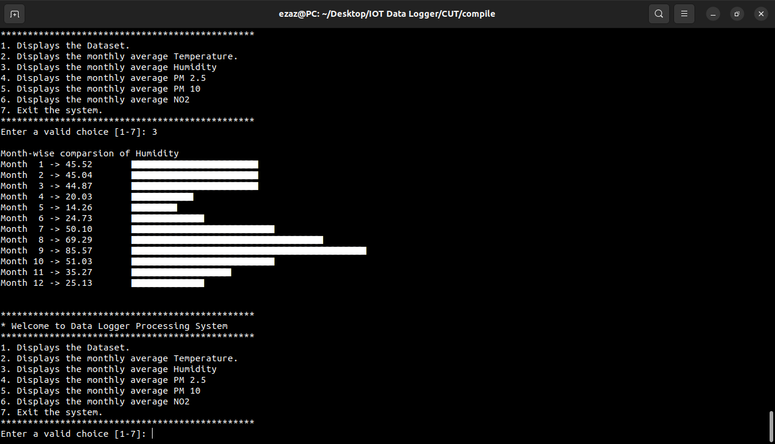

1. **Integration of avgPM25() in menu().**

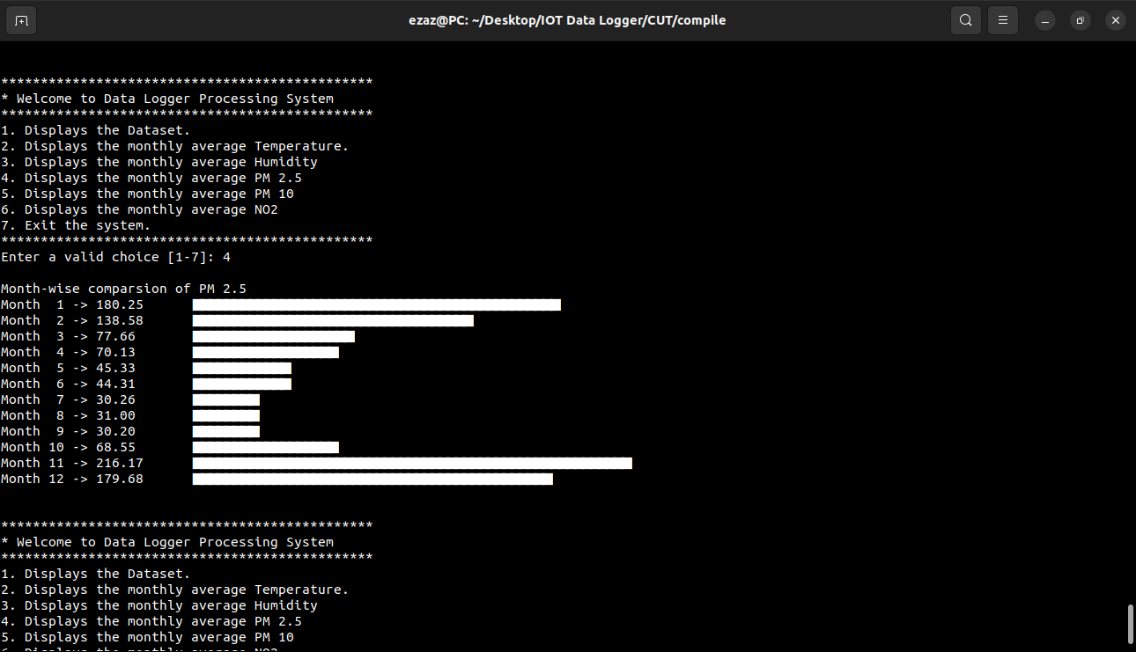

1. **Integration of avgPM10() in menu().**

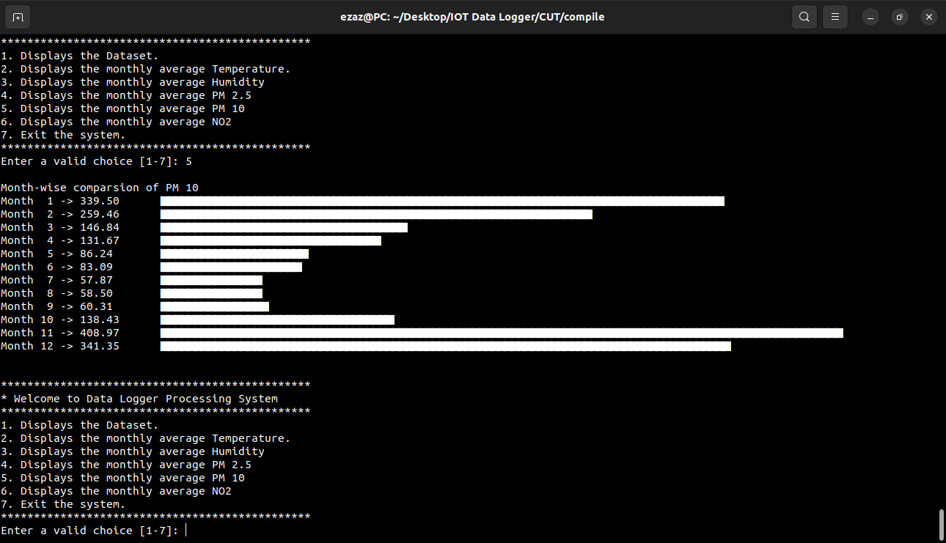

1. **Integration of avgNO2() in menu().**

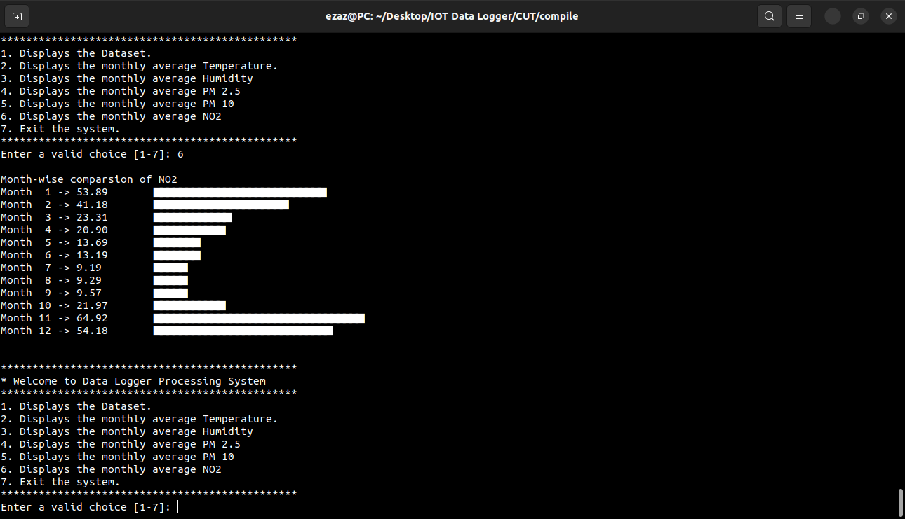

1. **Integration of appendLinkedList() in loadFromFile().**



1. **Integration of display_iotdata() in printLinkedList().**

